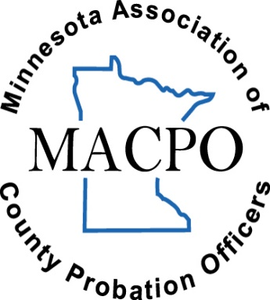
MACPO
Award Winners

Al Reker Distinguished Service Award
2024: Jason Andreson
2023: Tom Feddema | 2022: Margaret Munson
2021: Eric Johnson | 2020: Terry Fawcett
2018: Traci Green
2017: Brian Abrahamson | 2016: Jim Schneider
2015: Mike McGuire | 2014: John Klavins
2013: Stephen King | 2012: Curtis Johnson & Dennis Larson
2011: Joanne Pohl | 2010: Tammy Thompson
2009: Waren Liepitz | 2008: Mary Leach
2007: Melanie Courrier | 2006: Reno Wells
2005: Terryl Arola | 2004: Les Schultz
2003: Jay Hancuch | 2002: Pau Harris
2001: Lana Bjorgum
1999: Mike MacMillan | 1998: Elizabeth Burhans
1997: Richard Mulcrone | 1996: Therese McCoy
1995: Jerry Olson | 1994: Steve Paquay
1993: Barbara Richter | 1992: Roxanne Bartsh
1991: Quentin Rath | 1990: Dennis Miller
1989: Tim Cleveland | 1988: Steve Kley
1987: Myron Johnson | 1986: Steve Holmquist
1985: Rollie Lund | 1984: Jerry Weigenant
1983: John Jette | 1982: Lyle Pearson

Excellence in Corrections Award
2024: Rewind Inc.
2023: Wright County Gender Responsive Program | 2022: Mindy O’Brien
2021: Ottertail County DWI Court
2019: Grandmother’s Circles | 2018: Brown Nicollet Watonwan Drug Court
2017: Ottertail County DWI Court | 2016: Brown County Intensive Supervision Program
2014: Brown County Teen Court Program (Mary Ann Wonn)
2013: Prairie Lakes Youth Programs | 2012: Mower County Truancy Program (Tracy Bachman & Kelley Lang)
2011: Jenny Tonjum & Steele County Scram Program
2009: Village Ranch

2007: Steve Mattson

2005: Quan Enterprises, Inc. | 2004: Marlene & Buddy Gleason
2003: Tom Neilon

Outstanding Performance Award
2024: Chelsea Rabey
2023: Jami Tuve | 2022: Rhonda VanSchoonhoven
2021: Michelle Sellner | 2020: Travis Fisher
2019: Amy Hertzog | 2018: Marnie Humeniuk
2017: Brian Harris
2014: Chuck Kitzman
2013: Randy Baker | 2012: Bobbie Schafer
2011: Eric Johnson
2009: Abe Abrahamson
2007: Jill Hady
2005: Kari Ohman | 2004: Sharon Roemer
2003: Beth Soderman

Rookie Agent of the Year Award
2024: Rachel Deck
2023: Abby Skwira | 2022: Coltin Schmidt
2021: Rachel Scheid | 2020: Mckenzi Lorrig
2019: Jameson Nedved | 2018: Racheal Beckman
2017: Kaylee Henson | 2016: Laura Stylski
2014: Lindsey Cates
2013: Brad Schroeder

MACPO Superior Service Award
2024: Jonathan Schiro
2023: Devin Petersen | 2022: Michelle Nistler
2021: Michelle Pramman | 2020: Jill Ferretti
2019: Neal Huemoeller | 2018: Deanna Ruffing
2016: Jenny Tonjum
2014: Steve Paquay

EBP Trainer/Coach/Practitioner Award
2024: Edward Anderson
2023: Andrea Emery | 2022: Chris Papesh
2021: Rachel Miller

Spotlight Award
2024: Jessica Erickson
2023: Liz Miller-Gregor | 2022: Melanie Lupkes
2021: Trudy Miller | 2020: Dyanne Schuno
2019: Brenda Simonson | 2018: Jessica Miller

